Spike Outcome Report

Number: 07

Spike Title: Emergent Group Behaviour

Matthew Akom 7646720

**Goals**

Develop neighbour-aware agents that combine the weighted steering forces of wandering, separation, cohesion and alignment to create interesting emergent phenomena.

**Technologies, Tools and Resources Used**

* Python IDLE 3.6
* Lab 6 code
* Stack Overflow (some Python help)

**Tasks Undertaken**

* Expand upon Lab 6’s tasks by adding behaviour simulation
  + Alignment
  + Cohesion
  + Separation
* Add wandering behaviour from lab 6
* Combine all steering behaviours with weighted-sum
* Support adjustment of parameters in real time

**What I found out**

**Alignment code** – this took some time to get right as I was having difficulties getting the agents to align despite the code being seemingly correct.

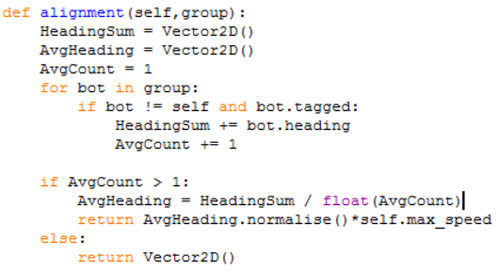

**Cohesion code**

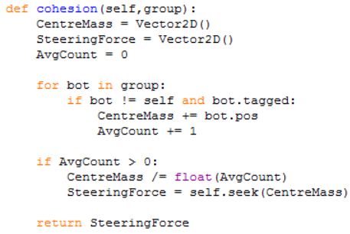

**Separation code**

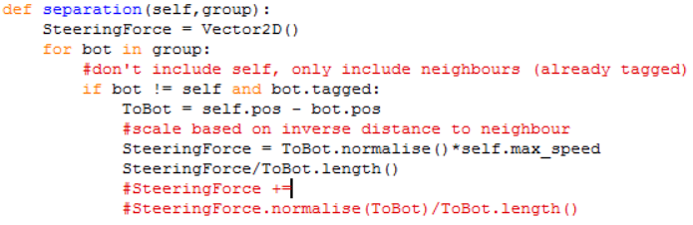

**Flocking code –** a weighted sum combination of *Alignment*, *Cohesion* and *Separation*.

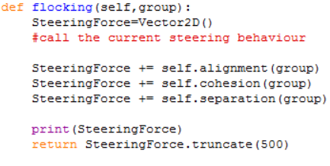

**Force calculation** – how the weighted sum is calculated

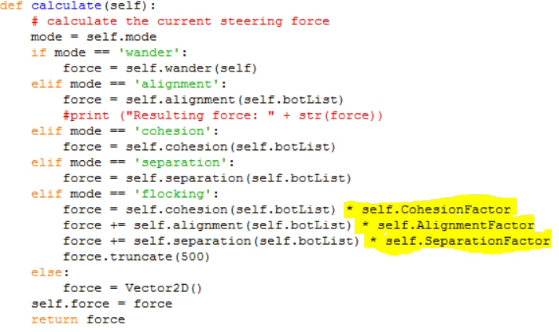

**Real-time adjustment of parameters**

To allow the user to adjust parameters in real time the code had to be written in such a way to account for both **existing** agents and **new** agents. The agents already on the screen had to have their parameters changed and then new agents needed to be built using those adjusted parameters instead of the defaults.

To accomplish this, I simply changed the parameters for the **existing agents** by looping through every agent in the world…

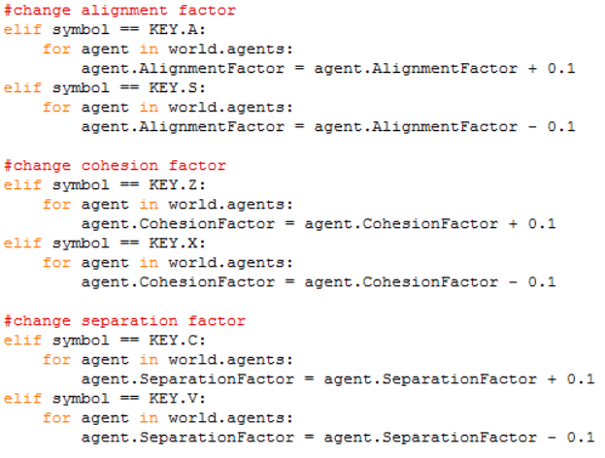

…then any new agent created is built using the variables from an agent already created in the world (as he will have the updated values). In this case I chose to use the last agent (list_name[-1]).

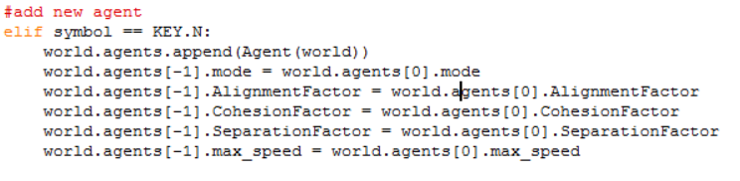

**Completed program**

**Wander**

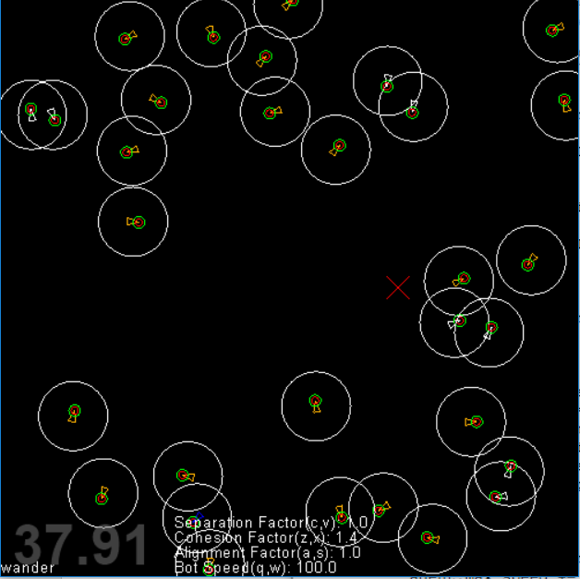

**Alignment**

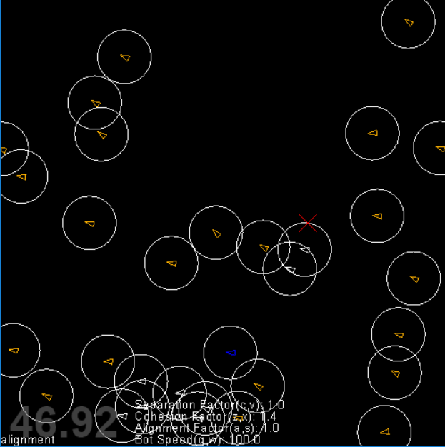

**Cohesion**

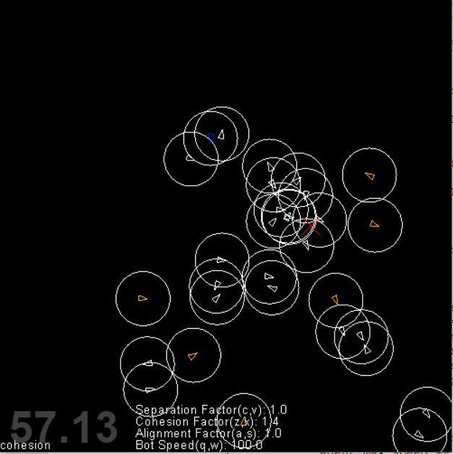

**Separation**

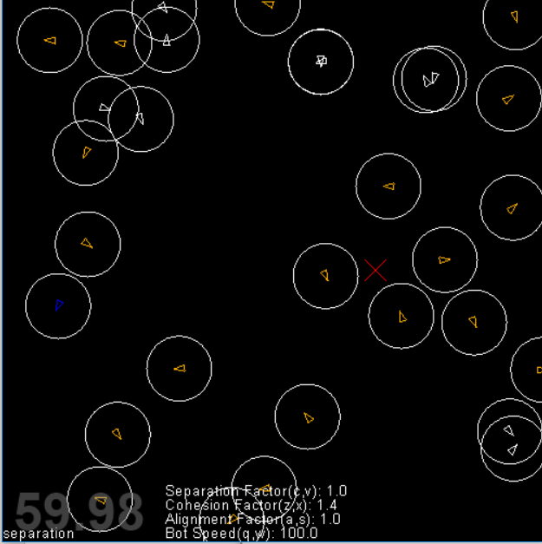

**Flocking (weighted sum)**

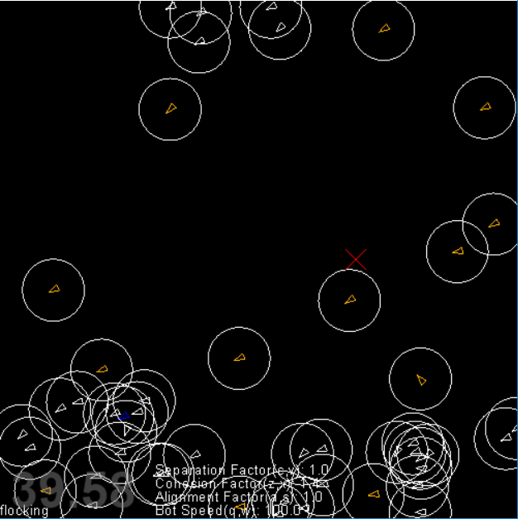

**Open Issues**

There are no open issues at the conclusion of this spike.